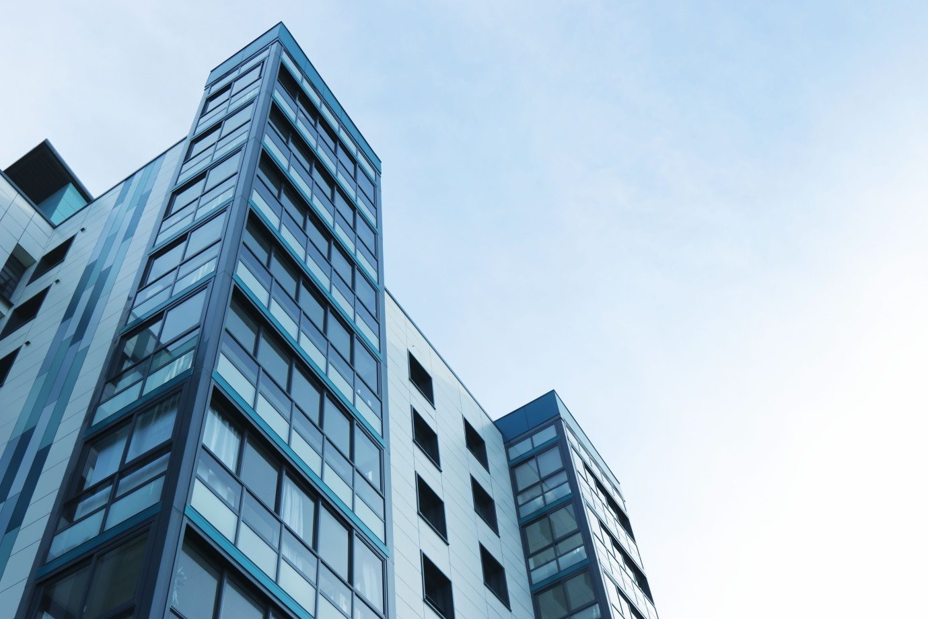

Address  
Street 123  
apt 123  
City. Country

www.yoursite.com

**BUSINESS**

**PLAN**